A Unified Interface for Free Fall Penetrometer: Technical Document
UI for Free Fall Penetrometer: Technical Document

Authors:
Vincent K. Ciccotelli
Project Developer, University of New Hampshire, Vincent.Ciccotelli@unh.edu
Rayya S. Burns
Project Developer, University of New Hampshire, Rayya.Burns@unh.edu
Brett R. Dupont
Project Developer, University of New Hampshire, Brett.Dupont@unh.edu
May A. Fallon
Project Developer, University of New Hampshire, May.Fallon@unh.edu
Troy Ciardelli-Zaryckyj
Project Developer, University of New Hampshire, Troy.Ciardelli-Zaryckyj@unh.edu
Anthony J. Snider
Project Developer, University of New Hampshire, Anthony.Snider@unh.edu

Introduction:
Our sponsor is Dr. Julie Paprocki, an assistant professor at the University of New Hampshire Civil and Environmental Engineering & Ocean Engineering department. Part of her research involves working directly with Free Fall Penetrometers, which are small, streamlined devices dropped into the ocean to measure deceleration rates and deduce soil type and characteristics. Understanding soil properties is important because offshore renewable energy technology is rapidly advancing, along with the need for it. Free Fall Penetrometers are used to measure these properties because they are significantly cheaper and easier to use than other methods. However, the Penetrometer only gathers raw data and provides no processing or insight, which is why Dr. Paprocki wants to build a unified user interface to perform this data processing. We were provided with a previously worked-on codebase that creates a desktop application to process raw Penetrometer data and display initial visualizations and calculations. Our vision is to continue developing this application by implementing relative density calculations, pore pressure properties, and other improvements to enhance the user experience. This provides value to our stakeholders by improving the application's usability and data processing tools. Our timeline and MOV are within one academic year; we want to build and improve upon the existing desktop application to incorporate two relative density calculations, along with expanded soil classification, friction angle calculation, and pore pressure properties. We split each of these features into their own respective epic and will consider our project successful if they are implemented correctly and approved by Dr. Paprocki.

Requirements:
- Functional
  - Allow the user to choose the directory where the generated PNG figure will be saved
    - DOD: User can save PNGs of graphs to wherever they choose.
    - Status: done
  - Automatically create a new, well-labeled folder for all CSV files generated for each new figure
    - DOD: Subfolders are appropriately named and automatically generated as the application runs.
    - Status: done
  - Drop points can be selected from visualized data
    - DOD: User is able to select any of the drop points available and cannot select invalid points.
    - Status: done
  - Graphs generated for important data analytics (drop points, spike, etc.)
    - DOD: Various graphs (aka corrected QSBC) are displayed and can be interacted with by a user.
    - Status: done
  - Graphs created have clearly defined labels
    - DOD: All labels on graphs show correct information and are easy to understand.
    - Status: done
  - Relative density calculations are correct and displayed
    - DOD: Both the Albatal and White density calculations are visible to the user upon selecting a peak and spike.
    - Status: done
  - Friction angle calculations are correct and displayed
    - DOD: Both the Jaber & Stark and Durgunoglu & Mitchell friction angle calculations are visible to the user upon selecting a peak, spike, and correction factor.
    - Status: done
  - Pore pressure properties are correct and displayed
    - DOD: Pore pressure properties are calculated correctly and displayed to the user upon selecting a peak, spike, and correction factor.
    - Status: Agreed to leave for next year's group
  - Important metrics and calculations are displayed in a (re)-organized manner
    - DOD: Important metrics such as relative density, friction angles, angles of tilt, QSBC plots, pore pressure properties, etc., are organized and displayed in the Sponsor’s desired fashion.
    - Status: done
- Nonfunctional
  - Intuitive user experience
  - Only valid inputs are processed
  - Time from user input to data output should be under three seconds
  - Need scalable process speeds and data visualization for growing input data sizes
  - Visual output should show desired data clearly

Design:
Architecture Diagram:
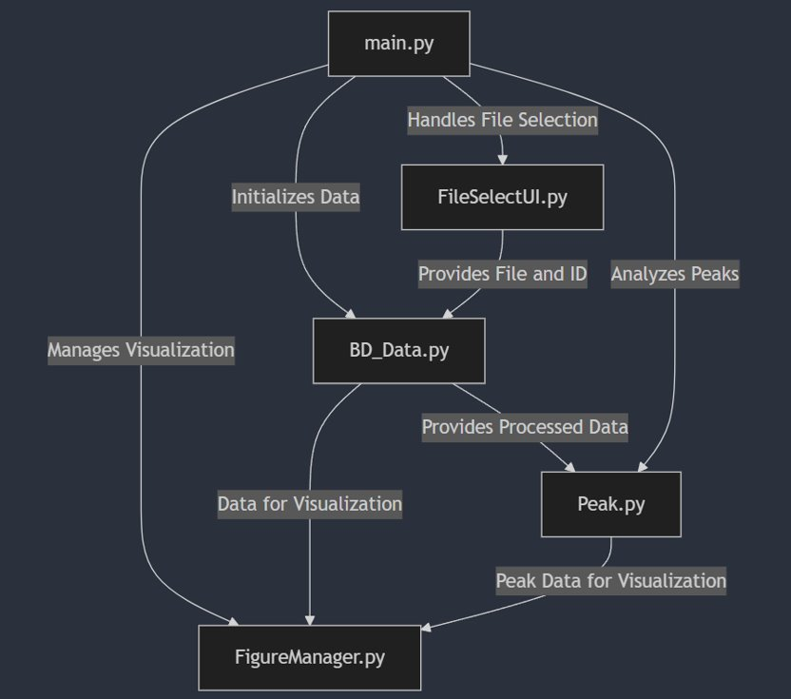
Figure 1: Simplified class diagram displaying the architecture
Main:
- Initializes FileSelectUI, Figure Manager.
- Directs the flow of the program.
- Handles user inputs.
FileSelectUI:
- Allows user to upload a .bin data file from desktop and select the BlueDrop ID associated with the data.
FigureManager:
- Singleton-like figure to display data when needed.
BD_Data:
- Represents a .bin data file associated with a BlueDrop ID to store accelerometer and pressure data.
Peak:
- Cropped version of BD_Data to perform specific calculations.

Dataflow Diagram:
Figure 2: Data flow diagram displaying how data interacts throughout the classes
Technical Rationale:
The implementation section of this document will get more into the details of how we exactly introduced the new functionality in this semester, however these involved discussions about how to best structure the code to make it more robust and easier to extend in the future. One example of this is how we restructured the code which generates and displays corrected QSBC lines. Prior to our changes, the function which produces the values of these lines were returned as a tuple and similarly passed into the display function as individual arguments, which bloated the function call with an excessive number of parameters. To fix this, we created a class which represents a QSBC line, and then used this new object to pass around the appropriate values for each line, making the code a lot more readable and robust.
Another great example of our team’s work toward making our codebase more robust and extendable comes from our implementation of the relative density formulas, which was a major part of our work this semester. As we have two formulas which are different but have the same goal – computing relative density, our team decided that it would be best to create a RelativeDensityFunction interface and then implement that interface in our two concrete implementations of the relative density calculations, named WhiteDensity and AlbatalDensity. This will allow future groups/individuals to easily add more relative density formulas if they need, and creates a much more organized codebase overall. Below is a small UML class diagram showcasing this relationship along with some extra information which will be discussed further in the Implementation section of our document.
We continued this same robust and scalable design pattern when implementing the friction angle calculations. Similar to our approach with relative density, we introduced a FrictionAngleFunction interface that defines a common structure for all friction angle computations. We then created concrete implementations for each method White et al., Albatal et al., and Durgunoglu and Mitchell ensuring that each formula adheres to the same interface while encapsulating its specific logic. Making it straightforward for future developers to incorporate additional friction angle correlations by simply implementing the interface, without modifying existing code.
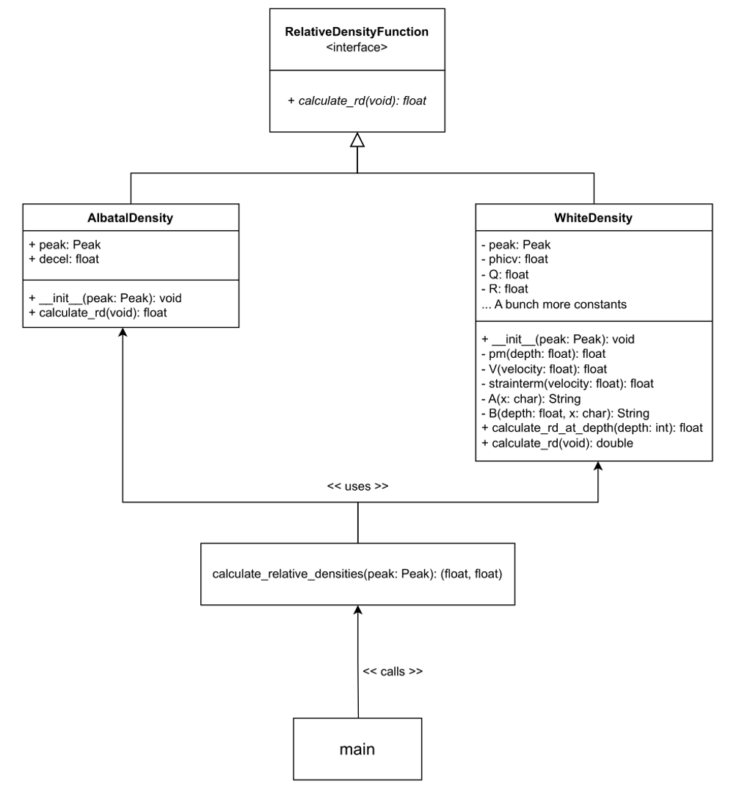
Figure 3: UML class diagram showing the relative density implementation and interface
Implementation:
Codebase Restructuring/Improvements:
Some of the work we focused on this semester was attempting to fix issues with the existing codebase or add onto unfinished features that the previous team was unable to complete before the end of the year.
Half of this work went towards the corrected QSBC lines/graph which is displayed to the user after they select a correction type. One issue that we fixed was that the QSBC graph displayed incorrect information when the beta correction factor was selected. The old code always calculated and displayed two corrected QSBC lines regardless of the correction factor selected, when only one corrected QSBC line should be calculated for the beta correction factor. The code was updated accordingly to handle this, and the label on the graph was also fixed with this change to correctly show the K or beta values that the corrected lines displayed have. Below is an example of that the updated graphs look like in the application.
Figure 3: Corrected QSBC graph with sine correction factor left, corrected QSBC graph with beta correction factor right
The other portion of this work went towards improving the storage of data and image files by the application. When we inherited this project, we noticed that various csv files are generated as the user navigates through the application and are all saved to one folder regardless of the scope or if it’s the same instance of the application. We decided it would be convenient for the user to have these files grouped into subfolders, so that each new peak selected will create a new folder for all its data to be dumped into. These subfolders are pre-named with the peak number, name of the raw datafile, and date to provide as much information as possible. The function of saving the graphs displayed as image files was not finished when we inherited the project, so we also implemented this, with the default naming scheme for the images generated following the same format as above.

Relative Density:
The major chunk of work our team focused on this semester was the implementation of two new calculations for a metric called Relative Density, which we want to display to the user, as well as use in later calculations and work when needed. The two calculations/formula implementations that we worked on were Albatal, and White et al.
As shown in the UML class diagram, we clearly have the previously mentioned class hierarchy, with the two density classes implementing the RelativeDensityFunction interface. To dive slightly deeper, although these two classes implement the discussed formulas as expected, one thing to note is that the Albatal formula is much simpler, and thus was much easier to implement. The White et al. formula, on the other hand, is much more complex and took our group a lot more time and effort to implement.
Additionally, the UML class diagram goes a bit further than just the interface and two classes, so let’s talk about why that is the case. Once the densities have been calculated and are ready to go, we need somewhere for them to go. That somewhere, for the time being, is just as some extra information displayed to the user on the QSBC display UI in our program. However, under the hood, we have to do some work to get them there. So, we created a calculate_relative_densities function which instantiates the two relative density formula classes with the necessary information (a Peak), and then calls the calculate_rd function on both, and stores their returns together in a pair of floats for ease of storage/retrieval. Then, the function just returns this pair. Then, finally, we can have main call this function when necessary to calculate and retrieve this pair of values (relative densities), and pass those values to the required classes/files to finish our process of displaying them to the user.
Friction Angle:
The friction angle calculations were one of the primary additions to the application performed during the spring semester. Having implemented the relative density calculations in the fall semester, we acknowledged that the friction angle formulas we had to implement were of a similar nature, and thus used the same architecture for setting up the various functions via an interface. Similar to the relative density, there were two functions to implement, one being fairly simple relying on less complex data from the peak, and the other being quite a rigorous calculation.
The first friction angle calculation implemented is known as the Density method, which relies on the relative density calculated in the previous step of the application. This method can take in either the Albatal or White relative density calculations and will produce a corresponding friction angle. This calculation also relies on some constants defined in Duncan et al. (2014), the normal stress, and atmospheric pressure, all of which we had to ensure were in the proper units for the calculation to return what we were expecting.
The secondary friction angle calculation we made was the Durgunoglu and Mitchell method, which was much more cumbersome to implement. This function pulled on much more of the peak data than the previous one, relying on fields such as maximum depth and the maximum value of the corrected QSBC line. Our sponsor provided us with an implementation of this method in MATLAB and we were tasked with converting it into Python and making it work with the rest of the data already contained in the application. This took some work, as we had to figure out exactly what in the provided code corresponded with values within our application. Additionally, we ran into some trouble as MATLAB has very unique math functions that don’t natively exist in Python, so we had to research the best way of going about performing these actions in Python. For trigonometry functions which work in degrees in MATLAB, we made helper functions just to simplify the code and make the language translation easier for us to work with. Towards the end of the calculation, the formula essentially needs to calculate the intersection point of two discrete functions, which is not something that can be done without some sort of external package. For this, we decided to go with the shapely package, which had a fairly easy-to-understand way of going about this problem that made it the best choice in our eyes. With this done, the implementation of this friction angle method was complete and was producing the value we expected for the given peak and parameters we usually work with when running the application.
Above is a screenshot of the final UI screen we added to clean everything up and add in new functionality relating to the quasi-static bearing capacity. This screen allows the user to input custom values for K and have the plot on the left update accordingly. This will be beneficial for users as it allows them to experiment with different values and see how the quasi-static bearing capacity reacts, enabling real-world simulations. The two blank plots on this screen have been left for next year’s group to implement and will include a pore pressure properties graph along with soil classification.
Testing:
We were left with a fairly well-designed testing structure which consists of two key files: (verify.py) and (test.py). verify.py contains a bunch of small functions that check whether the computed results (deceleration, velocity, depth, area, QSBC, pore pressure, etc.) match the expected known-correct values, which are stored in the provided MATLAB code. test.py runs the full pipeline; loading the data, selecting the peak, and then computing all the outputs and values the user might care about. Then, the verify functions are called from verify.py one by one for each component of the peak. We expanded this testing structure by adding tests into the verify.py file for both the White and Albatal relative density formulas, as well as all the friction angle calculations we implemented. We directly confirmed and reviewed the expected results of our tests with our sponsor Dr. Paprocki, ensuring our tests correctly validated the relative density and friction angle formulas.

Evaluation:
Our MVP for the year was to continue adding to the Free Fall Penetrometer user interface through the addition of the two relative density calculations, friction angle calculation, soil classification, pore pressure properties, and improvement to the overall navigational ease of the user interface. This was successfully met as determined through the following success criteria: the application is able to take input and accurately output the two relative density calculations and friction angle calculations, an improved user interface to ease navigation and use, and that the relative density calculations are able to be utilized for soil classifications. As we approached the end of our time working on the project, we also wanted to make sure the next group to work on it can pick up where we left off. We plan to leave the application in a good spot for future groups to understand current features and work on new features.

Appendices:
Version History:
 | S1 | S2
 | D1 | D2 | Final
Introduction | 3 | 3
Requirements | 2 | 3
Design | 2 | 3
Implementation / testing | 2 | 3
Evaluation / conclusions | 2 | 2

Codebase:
GitLab

Additional documentation:
1. Charter
2. User stories

